**East West University**

**Department of Computer Science & Engineering**

**A/2, Jahurul Islam Avenue, Jahurul Islam City, Aftabnagar, Dhaka-1212**

# _______________________________________________________________

**Lab Manual : 04**

**Course Code : CSE207**

**Course Title : Data Structures**

**Instructor : Md. Manowarul Islam, Adjunct Faculty, Department of CSE**

**Objective:**

The objective of this lab is to provide basic concept of linked list. At the end of the lab, students are able:

* To learn how to create a linked list
* To learn how to insert new nodes in linked list
* To learn how to delete a node from linked list.
* To learn how to reverse nodes of linked list.

**Linked list:**

A linked list is a sequence of data structures, which are connected together via links. Linked List is a sequence of links which contains items. Each link contains a connection to another link.

Linked list is the second most-used data structure after array.

Linked list can be visualized as a chain of nodes, where every node points to the next node.

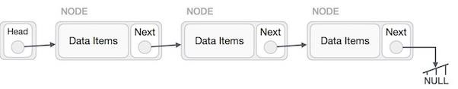

Now you have to perform the following lab task on linked list:

**Exercise 1:**

## Create a Menu

Create a menu that will display all the exercises given below (Exercise 2 to Exercise 8) as a list and prompt user to select any desired option. The menu can be designed in below format.

|  |
| --- |
| 1. Insert new node |
| 2. Insert node at beginning |
| 3. Insert node at any position……… |

**Exercise 2:**

## Create Linked List

Creating linked list is a more than one step activity. First, create a node using structure and find the location where it has to be inserted. Then input the data and store it in the allocated memory space. Use the pointer part of the node to point another node and insert the node at the end of the previously inserted node.

**Exercise 3:**

## Insert New Node at beginning

After completing exercise 1 you have a newly created linked list. Then take a new node and add it in the beginning of the linked list.

**Exercise 4:**

## Insert New Node at any position

Take a position number to insert a new node. Then take a new node and add it in the specified position number.

**Exercise 5:**

## Delete Node from last position

Delete the last node from the linked list and make the pointer part NULL of the previous node of the last node

**Exercise 6:**

***Delete Node from beginning*** Delete the first node.

**Exercise 7:**

## Delete Node from any position

Take a position number to delete a node from that position number.

**Exercise 8:**

## Reverse Linked list

You have to reverse the linked list in following format.

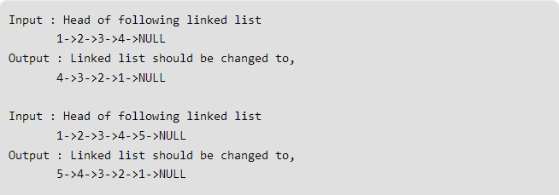

**Exercise 9:**

## Remove Duplicate data from Linked list

You have to remove all duplicate entry from your linked list. For this you have to create a list of data containing duplicate data and after executing, your program will provide a list, by removing all duplicate data.

**Example:**

**Input:** 1 2 1 1 2 3

**Output:** 1 2 3